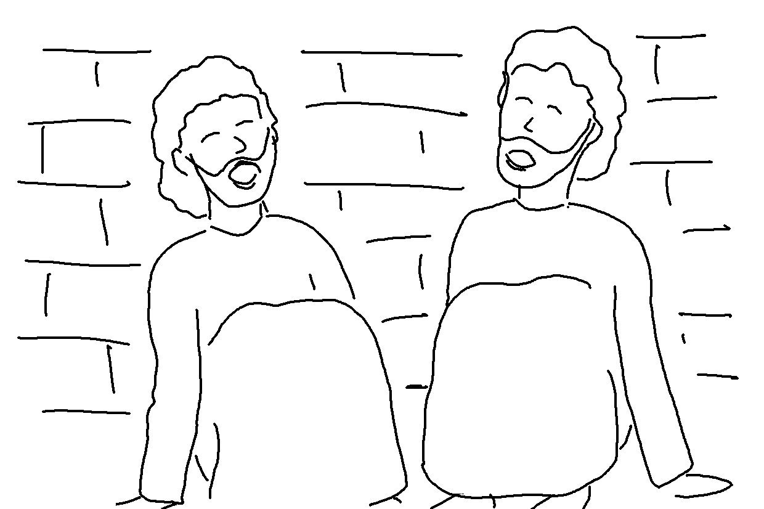
_ _ _ _ _ _ _ in the Lord Jesus and you will be _ _ _ _ _. Acts 16:31_{NLT}

